DIGITAL ELECTRONICS AND MICROPROCESSORS

Topic: 7-Segment Display and Decoder

SUBMITTED TO:

PROF. PADIMINI TN (DEM MENTOR)

SUBMITTED BY:

MUKUL DEV

(13BIT0269)

SLOT: A1

7-Segment Display and Decoder

An important component of the interface between humans and digital systems is the display of numeric (and alpha-numeric) information. A popular and relatively cheap numeric display device is the 7-segment display.

That uses three horizontal and four vertical bars to form the decimal digits from 0 to 9. Since numbers are stored in the form of strings of bits in digital systems, a decoder is needed to convert binary numbers to readable 7-segment patterns. The decoder may incorporate additional features such as blanking of leading zeros, lamp test, and a provision for brightness control.

Properties of the 7-Segment Display

The 74LS47 decoder circuit that we will use is designed to drive common anode 7-segment displays. The means that all positive ends (anodes) of the LED diodes are connected together to the positive end of a power supply and the negative ends (cathodes) of the LEDs are selectively pulled down to ground (through a resistor to limit the current) to light up the corresponding segment. Check the data sheet for the LDS-A414RI to check the labeling of the segments, the pin assignment for each segment and the maximum continuous forward current per segment.

In Multisim we will use the following component for animated simulations (i.e., simulations where the segments actually turn on and off depending on the signals applied to the component pins).

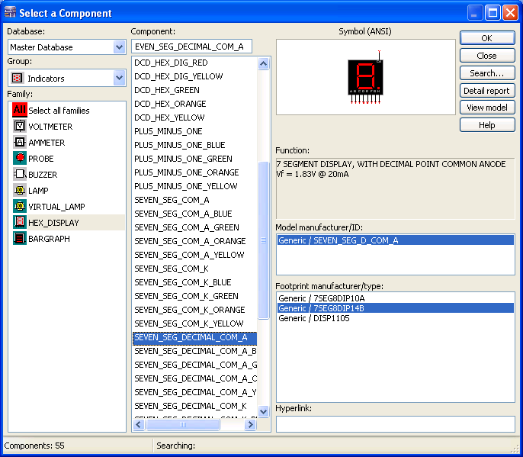

you will find that the pin assignments for the individual segments are not compatible with the LDS-A414RI 7-segment display component that we are using. The pin assignments for the SEVEN_SEG_DECIMAL_COM_A are shown in the schematic below.

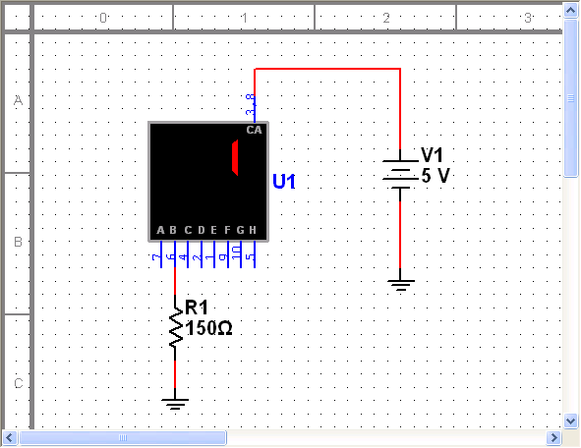

Thus, we have to create our own 7-segment display component as explained in Create LDS-A414RI. Unfortunately, National Instruments does not allow the creation of animated custom components so the 7-segment display component that you generate will have the correct footprint and will simulate correctly, but it will not show which segments are on or off depending on the applied signals. However, if you create the custom component according to the instructions in Create LDS-A414RI then you can change between the animated version and the version with the correct footprint using the "Replace Components..." command.

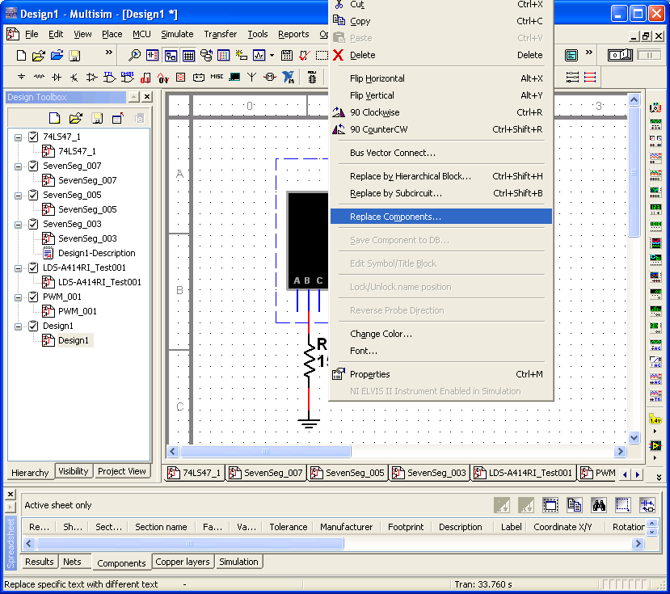

Generate the LDS-A414RI 7-segment display component (Create LDS-A414RI) and start a new design in Multisim as shown next.

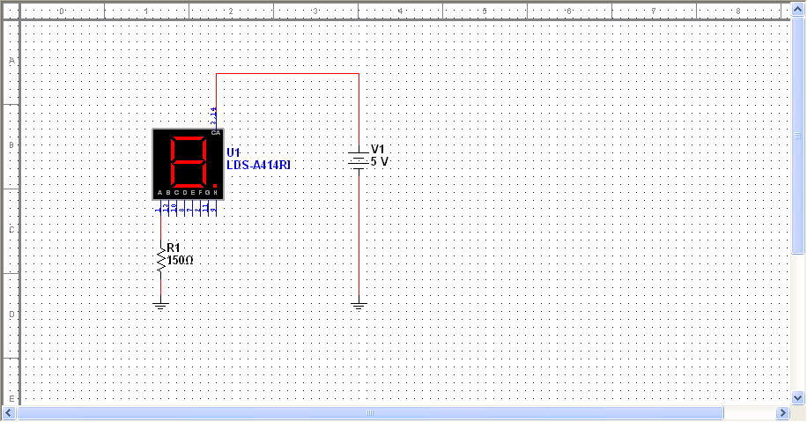

Determine the forward voltage across and the current through the LED for segment A for resistor (R1) values of 100, 120, 150, 180, 220, 270, and 330 ohms. For which resistor value is the current closest to 20 mA.

Characterization of the BCD to 7-Segment Decoder

Look at the 74LS47 datasheet to find out what exactly the 74LS47 BCD to 7-segment decoder is supposed to do. There is a truth table on page 3 of the datasheet that specifies the operation of the decoder. Note that there are 4 binary data inputs (A,B,C,D) and three control inputs (LT',RBI' and BI'/RBO'). To test the 74LS47, build the following schematic in Multisim. Note that this schematic uses the animated 7-segment display part.

Start testing with leaving switches F,G, and H open initially. Check that you can obtain the numbers 0...9 by operating the A,B,C,D switches (switch E controls the decimal point of the 7-segment display directly without going through the 74LS47 decoder). Then check the function of the F,G, and H switches and compare the results to the truth table in the 74LS47 datasheet. You should find that the 74LS47 model provided in Multisim does not operate correctly. Describe which feature(s) is/are not operating correctly.

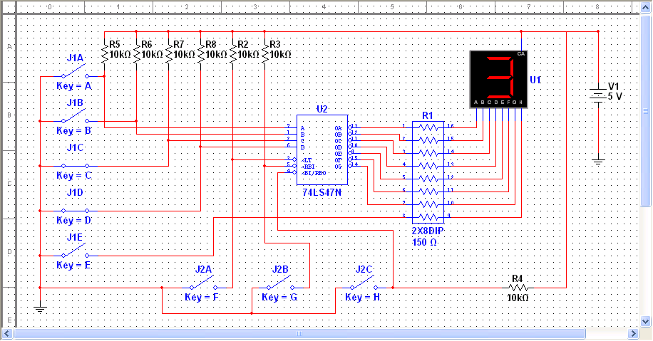

Save the 74LS47_1 component, which implements the correct function of the 74LS47, to the User Database. Then replace the original 74LS47 in the schematic above by the new 74LS47_1 as shown below.

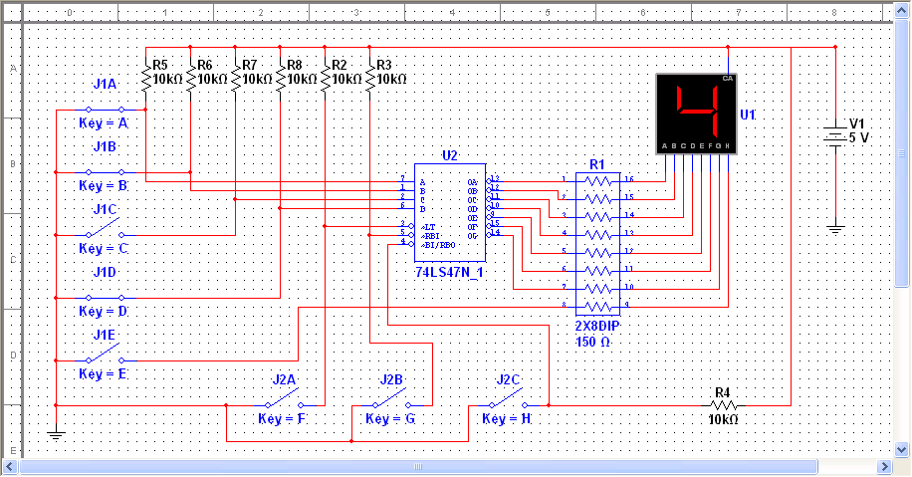

Now test the operation of the 74LS47 again and compare it again to the 74LS47 datasheet. And note that this would be applicable for the design of a digital clock.